Aaron Camp

Mod 5-2

The SELECT DAYNAME() function takes any date as an argument and returns what day of the week the selected date falls on. This could be used to list the current day of the week if you use the CURRENT_DATE() function as an argument. I can see this being useful in a script that runs to log information repeatedly to save the day of the week.

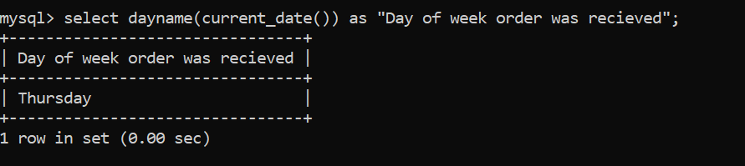

The TIMEDIFF() function takes two date values and returns the amount of time in between the two dates. The syntax of this function requires the format used for each argument to be the same. An example use case for this function would be finding out how much time after an order is received until it needs to be filled. Fictional Industries placed an order for 130 magic carpets on first_date, and they need them by the second_date. The TIMEDIFF() function would provide the timeframe available to produce and deliver the magic carpets to Fictional industries on time.

The SUBDATE() function takes a date as the first argument and an interval amount and unit for the second argument and it will return the date used as the first argument minus the interval entered in the second argument. A use case for this function could be to monitor how frequently something happens every ten days.

